EXPERIMENT : 02

TABLE CREATION AND VALUE INSERTION

Query :
- create table Instructor_56 (Instructor_id int primary key,Name varchar(30)NOT NULL,Department varchar(30));
desc Instructor_56;
- create table Course_56 (course_id int primary key,title varchar(30) NOT NULL,credits int CHECK(credits>0),instructor_id int,FOREIGN KEY(instructor_id)REFERENCES instructor_56(instructor_id));
desc Course_56;
- create table Student_56 (roll_no int primary key,Name varchar(30)NOT NULL,DoB date,department varchar(30));

desc Student_56;
- create table Enrollment_56 (roll_no int,course_id int,grade char(2),primary key(roll_no,course_id),FOREIGN KEY(roll_no)REFERENCES Student_56(roll_no)ON DELETE CASCADE,FOREIGN KEY(course_id)REFERENCES Course_56(course_id)ON DELETE CASCADE);
desc Enrollment_56;

Output :
- table INSTRUCTOR_56 created.

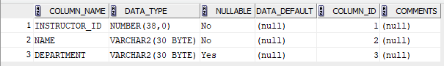

- table COURSE_56 created.

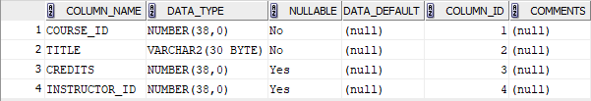

- table STUDENT_56 created.

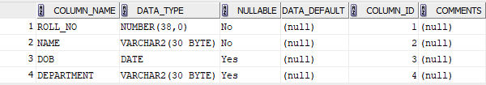

- table ENROLLMENT_56 created.

